**1. Download CUDA Toolkit**

At <https://developer.nvidia.com/cuda-downloads>, I’ve selected the following options. For the installer type, I’d choose (1) deb (local) if the Internet is available, (2) runfile (local) if unavailable. And then hit the “Download” button.

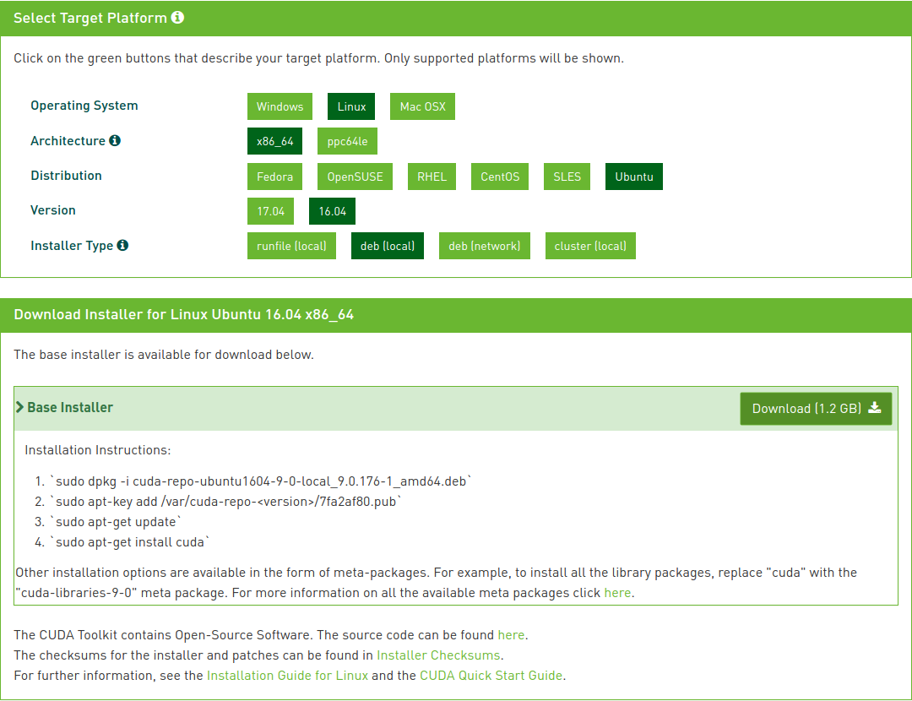

**2. Install CUDA Toolkit**

The base installer is available for download below.

1. `sudo dpkg -i cuda-repo-ubuntu1604-9-0-local_9.0.176-1_amd64.deb`  
2. `sudo apt-key add /var/cuda-repo-<version>/7fa2af80.pub`  
3. `sudo apt-get update`  
4. `sudo apt-get install cuda`  
  
If runfile (local) is chosen,  
1. Run `sudo sh cuda_8.0.44_linux.run`  
2. Follow the command-line prompts

### **nload Installer for Linux Ubuntu 16.04 x86_64**

**3. Download cuDNN**

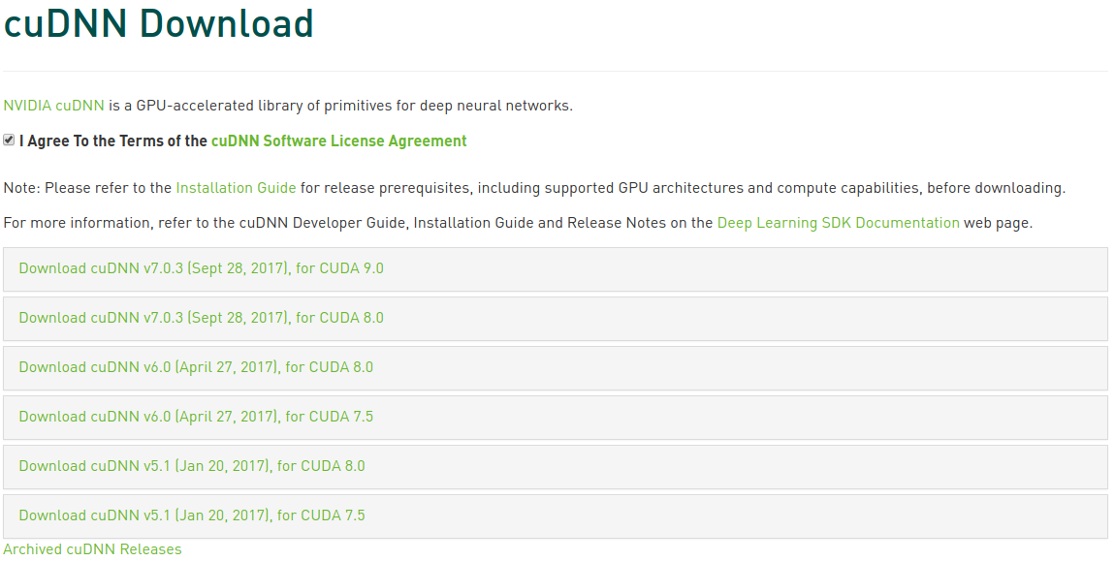

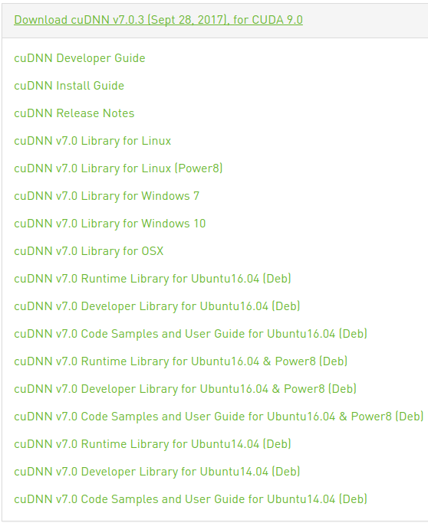

I downloaded

[cuDNN v7.0 Runtime Library for Ubuntu16.04 (Deb)](https://developer.nvidia.com/compute/machine-learning/cudnn/secure/v7.0.3/prod/9.0_20170926/Ubuntu16_04-x64/libcudnn7_7.0.3.11-1+cuda9.0_amd64-deb)

[cuDNN v7.0 Developer Library for Ubuntu16.04 (Deb)](https://developer.nvidia.com/compute/machine-learning/cudnn/secure/v7.0.3/prod/9.0_20170926/Ubuntu16_04-x64/libcudnn7-dev_7.0.3.11-1+cuda9.0_amd64-deb)

[cuDNN v7.0 Code Samples and User Guide for Ubuntu16.04 (Deb)](https://developer.nvidia.com/compute/machine-learning/cudnn/secure/v7.0.3/prod/9.0_20170926/Ubuntu16_04-x64/libcudnn7-doc_7.0.3.11-1+cuda9.0_amd64-deb)

**4. Install cuDNN**

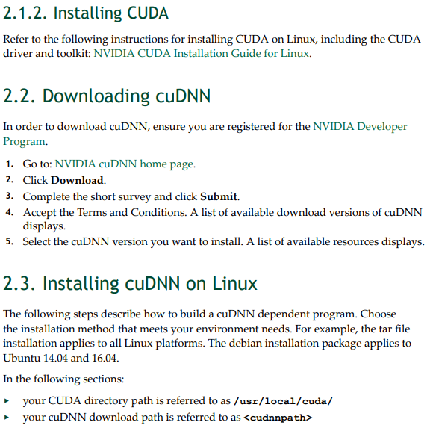

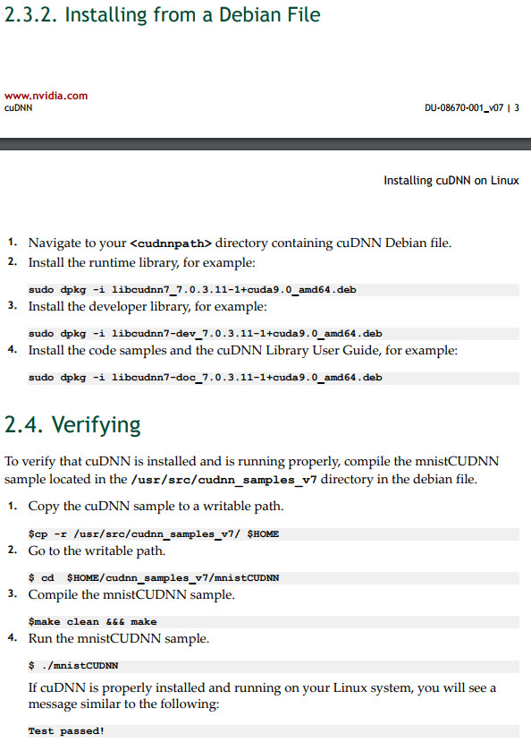

The log is as follows.

(tensorflow-gpu) mrtonnet@ubuntu-gpu-office:~$ python word2vec_basic.py

Traceback (most recent call last):

File "word2vec_basic.py", line 31, in <module>

import tensorflow as tf

File "/home/mrtonnet/tensorflow-gpu/local/lib/python2.7/site-packages/tensorflow/__init__.py", line 24, in <module>

from tensorflow.python import *

File "/home/mrtonnet/tensorflow-gpu/local/lib/python2.7/site-packages/tensorflow/python/__init__.py", line 49, in <module>

from tensorflow.python import pywrap_tensorflow

File "/home/mrtonnet/tensorflow-gpu/local/lib/python2.7/site-packages/tensorflow/python/pywrap_tensorflow.py", line 72, in <module>

raise ImportError(msg)

ImportError: Traceback (most recent call last):

File "/home/mrtonnet/tensorflow-gpu/local/lib/python2.7/site-packages/tensorflow/python/pywrap_tensorflow.py", line 58, in <module>

from tensorflow.python.pywrap_tensorflow_internal import *

File "/home/mrtonnet/tensorflow-gpu/local/lib/python2.7/site-packages/tensorflow/python/pywrap_tensorflow_internal.py", line 28, in <module>

_pywrap_tensorflow_internal = swig_import_helper()

File "/home/mrtonnet/tensorflow-gpu/local/lib/python2.7/site-packages/tensorflow/python/pywrap_tensorflow_internal.py", line 24, in swig_import_helper

_mod = imp.load_module('_pywrap_tensorflow_internal', fp, pathname, description)

**ImportError: libcublas.so.8.0: cannot open shared object file: No such file or directory**

Failed to load the native TensorFlow runtime.

See https://www.tensorflow.org/install/install_sources#common_installation_problems

for some common reasons and solutions. Include the entire stack trace

above this error message when asking for help.

(tensorflow-gpu) mrtonnet@ubuntu-gpu-office:~$ cd Downloads/

(tensorflow-gpu) mrtonnet@ubuntu-gpu-office:~/Downloads$ l

170703.pdf cuda-repo-ubuntu1604-9-0-local_9.0.176-1_amd64.deb

(tensorflow-gpu) mrtonnet@ubuntu-gpu-office:~/Downloads$ sudo dpkg -i cuda-repo-ubuntu1604-9-0-local_9.0.176-1_amd64.deb

sudo: unable to resolve host ubuntu-gpu-office

[sudo] password for mrtonnet:

(Reading database ... 226492 files and directories currently installed.)

Preparing to unpack cuda-repo-ubuntu1604-9-0-local_9.0.176-1_amd64.deb ...

Unpacking cuda-repo-ubuntu1604-9-0-local (9.0.176-1) over (9.0.176-1) ...

Setting up cuda-repo-ubuntu1604-9-0-local (9.0.176-1) …

(tensorflow-gpu) mrtonnet@ubuntu-gpu-office:~/Downloads$ sudo apt-key add /var/cuda-repo-9-0-local/7fa2af80.pub

**sudo: unable to resolve host ubuntu-gpu-office**

OK

(tensorflow-gpu) mrtonnet@ubuntu-gpu-office:~/Downloads$ sudo apt-get update

**sudo: unable to resolve host ubuntu-gpu-office**

Get:1 file:/var/cuda-repo-9-0-local InRelease

Ign:1 file:/var/cuda-repo-9-0-local InRelease

Get:2 file:/var/cuda-repo-9-0-local Release [574 B]

Get:2 file:/var/cuda-repo-9-0-local Release [574 B]

Hit:4 https://download.docker.com/linux/ubuntu xenial InRelease

Ign:5 http://dl.google.com/linux/chrome/deb stable InRelease

Hit:6 http://dl.google.com/linux/chrome/deb stable Release

Get:7 http://security.ubuntu.com/ubuntu xenial-security InRelease [102 kB]

Hit:9 http://us.archive.ubuntu.com/ubuntu xenial InRelease

Get:10 http://us.archive.ubuntu.com/ubuntu xenial-updates InRelease [102 kB]

Get:11 http://security.ubuntu.com/ubuntu xenial-security/main amd64 DEP-11 Metadata [60.3 kB]

Get:12 http://us.archive.ubuntu.com/ubuntu xenial-backports InRelease [102 kB]

Get:13 http://us.archive.ubuntu.com/ubuntu xenial-updates/main amd64 Packages [651 kB]

Get:14 http://security.ubuntu.com/ubuntu xenial-security/main DEP-11 64x64 Icons [57.6 kB]

Get:15 http://security.ubuntu.com/ubuntu xenial-security/universe amd64 Packages [178 kB]

Get:16 http://security.ubuntu.com/ubuntu xenial-security/universe i386 Packages [153 kB]

Get:17 http://security.ubuntu.com/ubuntu xenial-security/universe Translation-en [94.3 kB]

Get:18 http://security.ubuntu.com/ubuntu xenial-security/universe amd64 DEP-11 Metadata [49.7 kB]

Get:19 http://security.ubuntu.com/ubuntu xenial-security/universe DEP-11 64x64 Icons [75.1 kB]

Get:20 http://us.archive.ubuntu.com/ubuntu xenial-updates/main i386 Packages [617 kB]

Get:21 http://us.archive.ubuntu.com/ubuntu xenial-updates/main amd64 DEP-11 Metadata [307 kB]

Get:22 http://us.archive.ubuntu.com/ubuntu xenial-updates/main DEP-11 64x64 Icons [213 kB]

Get:23 http://us.archive.ubuntu.com/ubuntu xenial-updates/universe amd64 Packages [543 kB]

Get:24 http://us.archive.ubuntu.com/ubuntu xenial-updates/universe i386 Packages [517 kB]

Get:25 http://us.archive.ubuntu.com/ubuntu xenial-updates/universe amd64 DEP-11 Metadata [173 kB]

Get:26 http://us.archive.ubuntu.com/ubuntu xenial-updates/universe DEP-11 64x64 Icons [236 kB]

Get:27 http://us.archive.ubuntu.com/ubuntu xenial-updates/multiverse amd64 DEP-11 Metadata [5,888 B]

Get:28 http://us.archive.ubuntu.com/ubuntu xenial-backports/main amd64 DEP-11 Metadata [3,324 B]

Get:29 http://us.archive.ubuntu.com/ubuntu xenial-backports/universe amd64 DEP-11 Metadata [4,588 B]

Fetched 4,245 kB in 19s (216 kB/s)

Reading package lists... Done

(tensorflow-gpu) mrtonnet@ubuntu-gpu-office:~/Downloads$ sudo apt-get install cuda

**sudo: unable to resolve host ubuntu-gpu-office**

Reading package lists... Done

Building dependency tree

Reading state information... Done

cuda is already the newest version (9.0.176-1).

0 upgraded, 0 newly installed, 0 to remove and 35 not upgraded.

1 not fully installed or removed.

After this operation, 0 B of additional disk space will be used.

Do you want to continue? [Y/n] y

Setting up veraport (1.1.0.2) ...

**ln: target '/usr/lib/mozilla/plugins/' is not a directory: No such file or directory**

**dpkg: error processing package veraport (--configure):**

**subprocess installed post-installation script returned error exit status 1**

**Errors were encountered while processing:**

**veraport**

**E: Sub-process /usr/bin/dpkg returned an error code (1)**

(tensorflow-gpu) mrtonnet@ubuntu-gpu-office:~/Downloads$ ls

cuda-repo-ubuntu1604-9-0-local_9.0.176-1_amd64.deb

cuDNN-Developer-Guide.pdf

cuDNN-Installation-Guide.pdf

cuDNN-Release-Notes.pdf

libcudnn7_7.0.3.11-1+cuda9.0_amd64.deb

libcudnn7-dev_7.0.3.11-1+cuda9.0_amd64.deb

libcudnn7-doc_7.0.3.11-1+cuda9.0_amd64.deb

(tensorflow-gpu) mrtonnet@ubuntu-gpu-office:~/Downloads**$ sudo dpkg -i libcudnn7_7.0.3.11-1+cuda9.0_amd64.deb**

sudo: unable to resolve host ubuntu-gpu-office

Selecting previously unselected package libcudnn7.

(Reading database ... 226492 files and directories currently installed.)

Preparing to unpack libcudnn7_7.0.3.11-1+cuda9.0_amd64.deb ...

Unpacking libcudnn7 (7.0.3.11-1+cuda9.0) ...

Setting up libcudnn7 (7.0.3.11-1+cuda9.0) ...

Processing triggers for libc-bin (2.23-0ubuntu9) ...

/sbin/ldconfig.real: /usr/lib/nvidia-384/libEGL.so.1 is not a symbolic link

/sbin/ldconfig.real: /usr/lib32/nvidia-384/libEGL.so.1 is not a symbolic link

(tensorflow-gpu) mrtonnet@ubuntu-gpu-office:~/Downloads$ sudo dkpg -i libcudnn7-dev_7.0.3.11-1+cuda9.0_amd64.deb

sudo: unable to resolve host ubuntu-gpu-office

sudo: dkpg: command not found

(tensorflow-gpu) mrtonnet@ubuntu-gpu-office:~/Downloads$ sudo dpkg -i libcudnn7-dev_7.0.3.11-1+cuda9.0_amd64.deb

sudo: unable to resolve host ubuntu-gpu-office

Selecting previously unselected package libcudnn7-dev.

(Reading database ... 226498 files and directories currently installed.)

Preparing to unpack libcudnn7-dev_7.0.3.11-1+cuda9.0_amd64.deb ...

Unpacking libcudnn7-dev (7.0.3.11-1+cuda9.0) ...

Setting up libcudnn7-dev (7.0.3.11-1+cuda9.0) ...

update-alternatives: using /usr/include/x86_64-linux-gnu/cudnn_v7.h to provide /usr/include/cudnn.h (libcudnn) in auto mode

(tensorflow-gpu) mrtonnet@ubuntu-gpu-office:~/Downloads$ sudo dpkg

dpkg dpkg-gencontrol dpkg-reconfigure

dpkg-architecture dpkg-gensymbols dpkg-scanpackages

dpkg-buildflags dpkg-log-summary dpkg-scansources

dpkg-buildpackage dpkg-maintscript-helper dpkg-shlibdeps

dpkg-checkbuilddeps dpkg-mergechangelogs dpkg-source

dpkg-deb dpkg-name dpkg-split

dpkg-distaddfile dpkg-parsechangelog dpkg-statoverride

dpkg-divert dpkg-preconfigure dpkg-trigger

dpkg-genchanges dpkg-query dpkg-vendor

(tensorflow-gpu) mrtonnet@ubuntu-gpu-office:~/Downloads$ sudo dpkg -i libcudnn7-doc_7.0.3.11-1+cuda9.0_amd64.deb

sudo: unable to resolve host ubuntu-gpu-office

Selecting previously unselected package libcudnn7-doc.

(Reading database ... 226504 files and directories currently installed.)

Preparing to unpack libcudnn7-doc_7.0.3.11-1+cuda9.0_amd64.deb ...

Unpacking libcudnn7-doc (7.0.3.11-1+cuda9.0) ...

Setting up libcudnn7-doc (7.0.3.11-1+cuda9.0) ...

(tensorflow-gpu) mrtonnet@ubuntu-gpu-office:~/Downloads$ ls /usr/src/cudnn_samples_v7/

mnistCUDNN RNN

(tensorflow-gpu) mrtonnet@ubuntu-gpu-office:~/Downloads$ cp -r /usr/src/cudnn_samples_v7/ $HOME

(tensorflow-gpu) mrtonnet@ubuntu-gpu-office:~/Downloads$ cd ..

(tensorflow-gpu) mrtonnet@ubuntu-gpu-office:~$ l

1-work/ Desktop/ Public/ word2vec_basic.py

bin/ Documents/ temp/ xmind-8-update5-linux/

connect_aws-oregon* Downloads/ Templates/

connect_aws-seoul* Music/ tensorflow-gpu/

cudnn_samples_v7/ Pictures/ Videos/

(tensorflow-gpu) mrtonnet@ubuntu-gpu-office:~$ cd cudnn_samples_v7/mnistCUDNN/

(tensorflow-gpu) mrtonnet@ubuntu-gpu-office:~/cudnn_samples_v7/mnistCUDNN$ l

data/ fp16_dev.cu fp16_emu.cpp FreeImage/ Makefile readme.txt

error_util.h fp16_dev.h fp16_emu.h gemv.h mnistCUDNN.cpp

(tensorflow-gpu) mrtonnet@ubuntu-gpu-office:~/cudnn_samples_v7/mnistCUDNN$ make clean &&& make

bash: syntax error near unexpected token `&'

(tensorflow-gpu) mrtonnet@ubuntu-gpu-office:~/cudnn_samples_v7/mnistCUDNN$ make clean &&& make

bash: syntax error near unexpected token `&'

(tensorflow-gpu) mrtonnet@ubuntu-gpu-office:~/cudnn_samples_v7/mnistCUDNN$ make clean

rm -rf *o

rm -rf mnistCUDNN

(tensorflow-gpu) mrtonnet@ubuntu-gpu-office:~/cudnn_samples_v7/mnistCUDNN$ make

/usr/local/cuda/bin/nvcc -ccbin g++ -I/usr/local/cuda/include -IFreeImage/include -m64 -gencode arch=compute_30,code=sm_30 -gencode arch=compute_35,code=sm_35 -gencode arch=compute_50,code=sm_50 -gencode arch=compute_53,code=sm_53 -gencode arch=compute_53,code=compute_53 -o fp16_dev.o -c fp16_dev.cu

g++ -I/usr/local/cuda/include -IFreeImage/include -o fp16_emu.o -c fp16_emu.cpp

g++ -I/usr/local/cuda/include -IFreeImage/include -o mnistCUDNN.o -c mnistCUDNN.cpp

/usr/local/cuda/bin/nvcc -ccbin g++ -m64 -gencode arch=compute_30,code=sm_30 -gencode arch=compute_35,code=sm_35 -gencode arch=compute_50,code=sm_50 -gencode arch=compute_53,code=sm_53 -gencode arch=compute_53,code=compute_53 -o mnistCUDNN fp16_dev.o fp16_emu.o mnistCUDNN.o -LFreeImage/lib/linux/x86_64 -LFreeImage/lib/linux -lcudart -lcublas -lcudnn -lfreeimage -lstdc++ -lm

(tensorflow-gpu) mrtonnet@ubuntu-gpu-office:~/cudnn_samples_v7/mnistCUDNN$ l

data/ fp16_dev.h fp16_emu.h gemv.h mnistCUDNN.cpp

error_util.h fp16_dev.o fp16_emu.o Makefile mnistCUDNN.o

fp16_dev.cu fp16_emu.cpp FreeImage/ mnistCUDNN* readme.txt

(tensorflow-gpu) mrtonnet@ubuntu-gpu-office:~/cudnn_samples_v7/mnistCUDNN$ ./mnistCUDNN

cudnnGetVersion() : 7003 , CUDNN_VERSION from cudnn.h : 7003 (7.0.3)

Host compiler version : GCC 5.4.0

There are 2 CUDA capable devices on your machine :

device 0 : sms 28 Capabilities 6.1, SmClock 1582.0 Mhz, MemSize (Mb) 11171, MemClock 5505.0 Mhz, Ecc=0, boardGroupID=0

device 1 : sms 28 Capabilities 6.1, SmClock 1582.0 Mhz, MemSize (Mb) 11172, MemClock 5505.0 Mhz, Ecc=0, boardGroupID=1

Using device 0

Testing single precision

Loading image data/one_28x28.pgm

Performing forward propagation ...

Testing cudnnGetConvolutionForwardAlgorithm ...

Fastest algorithm is Algo 1

Testing cudnnFindConvolutionForwardAlgorithm ...

^^^^ CUDNN_STATUS_SUCCESS for Algo 0: 0.021504 time requiring 0 memory

^^^^ CUDNN_STATUS_SUCCESS for Algo 1: 0.025600 time requiring 3464 memory

^^^^ CUDNN_STATUS_SUCCESS for Algo 2: 0.034816 time requiring 57600 memory

^^^^ CUDNN_STATUS_SUCCESS for Algo 7: 0.073728 time requiring 2057744 memory

^^^^ CUDNN_STATUS_SUCCESS for Algo 5: 0.098304 time requiring 203008 memory

Resulting weights from Softmax:

0.0000000 0.9999399 0.0000000 0.0000000 0.0000561 0.0000000 0.0000012 0.0000017 0.0000010 0.0000000

Loading image data/three_28x28.pgm

Performing forward propagation ...

Resulting weights from Softmax:

0.0000000 0.0000000 0.0000000 0.9999288 0.0000000 0.0000711 0.0000000 0.0000000 0.0000000 0.0000000

Loading image data/five_28x28.pgm

Performing forward propagation ...

Resulting weights from Softmax:

0.0000000 0.0000008 0.0000000 0.0000002 0.0000000 0.9999820 0.0000154 0.0000000 0.0000012 0.0000006

Result of classification: 1 3 5

Test passed!

Testing half precision (math in single precision)

Loading image data/one_28x28.pgm

Performing forward propagation ...

Testing cudnnGetConvolutionForwardAlgorithm ...

Fastest algorithm is Algo 1

Testing cudnnFindConvolutionForwardAlgorithm ...

^^^^ CUDNN_STATUS_SUCCESS for Algo 0: 0.023296 time requiring 0 memory

^^^^ CUDNN_STATUS_SUCCESS for Algo 1: 0.028992 time requiring 3464 memory

^^^^ CUDNN_STATUS_SUCCESS for Algo 2: 0.038912 time requiring 28800 memory

^^^^ CUDNN_STATUS_SUCCESS for Algo 7: 0.071680 time requiring 2057744 memory

^^^^ CUDNN_STATUS_SUCCESS for Algo 5: 0.107520 time requiring 203008 memory

Resulting weights from Softmax:

0.0000001 1.0000000 0.0000001 0.0000000 0.0000563 0.0000001 0.0000012 0.0000017 0.0000010 0.0000001

Loading image data/three_28x28.pgm

Performing forward propagation ...

Resulting weights from Softmax:

0.0000000 0.0000000 0.0000000 1.0000000 0.0000000 0.0000714 0.0000000 0.0000000 0.0000000 0.0000000

Loading image data/five_28x28.pgm

Performing forward propagation ...

Resulting weights from Softmax:

0.0000000 0.0000008 0.0000000 0.0000002 0.0000000 1.0000000 0.0000154 0.0000000 0.0000012 0.0000006

Result of classification: 1 3 5

Test passed!

(tensorflow-gpu) mrtonnet@ubuntu-gpu-office:~/cudnn_samples_v7/mnistCUDNN$